**Assignment No 1:**

Title: Study the Google Cloud Platform.

Theory: link (<https://cloud.google.com/docs>)(<https://www.youtube.com/playlist?list=PLIivdWyY5sqIUkH9XhgMkAOyIwCN4H0As>)

**What Is Cloud Computing?**

[Cloud computing](https://intellipaat.com/blog/tutorial/amazon-web-services-aws-tutorial/definition-of-cloud-computing/), in simple words, is accessing and storing data over the Internet instead of doing it on your personal hard drive.

It offers services like [storage](https://intellipaat.com/blog/tutorial/amazon-web-services-aws-tutorial/storage-and-content-delivery/), database, networking, and more over the Internet to provide faster, innovative, and flexible resources to its customers. The customers get to pay only for the resources they use, hence helping them lower their operating costs and run their business infrastructure more efficiently.

Now, among various cloud providers like AWS, Microsoft, VMWare, IBM, etc., Google Cloud has been the talk of the town in recent years and there are enough reasons behind it. Let’s begin with starters and understand what Google Cloud is.

***Here is a blog on ‘[Whatis cloud computing](https://intellipaat.com/blog/what-is-cloud-computing/" \t "_blank)‘.***

**What Is Google Cloud Platform?**

Google Cloud is a suite of Cloud Computing services offered by Google. The platform provides various services like compute, storage, networking, [Big Data](https://intellipaat.com/blog/tutorial/big-data-and-hadoop-tutorial/), and many more that run on the same infrastructure that Google uses internally for its end users like Google Search and YouTube.

Google server hasn’t gone down in years. So, if you are planning to run your application on the Google Cloud infrastructure, then you can be assured of your applications being safe and secure.

# About Google Cloud services (<https://cloud.google.com/docs/overview/cloud-platform-services>)

This overview introduces some of the commonly used Google Cloud services. For the full list of services, see the [Products and services page](https://cloud.google.com/products).

This overview covers the following types of services:

* [Computing and hosting](https://cloud.google.com/docs/overview/cloud-platform-services#computing-hosting)
* [Storage](https://cloud.google.com/docs/overview/cloud-platform-services#storage)
* [Databases](https://cloud.google.com/docs/overview/cloud-platform-services#databases)
* [Networking](https://cloud.google.com/docs/overview/cloud-platform-services#networking)
* [Big data](https://cloud.google.com/docs/overview/cloud-platform-services#big-data)
* [Machine learning](https://cloud.google.com/docs/overview/cloud-platform-services#machine-learning)

OUT of Google Product you have to study 3 services in detail:

* 1. Compute (<https://cloud.google.com/docs#section-7>)
     1. In compute write detail steps of how to create a Linux virtual machine instance in Compute Engine using the Google Cloud Console. ( Reference: <https://cloud.google.com/compute/docs/quickstart-linux> )

Steps :

* Open url cloud.google.com
* Click on console on right corner of page.
* In the Cloud Console, go to the **VM Instances** page.
* Click **Create instance**.
* In the **Boot disk** section, click **Change** to begin configuring your boot disk.
* On the **Public images** tab, choose **Debian version 9**.
* Click **Select**.
* In the **Firewall** section, select **Allow HTTP traffic**.
* Click **Create** to create the instance.
* Allow a short time for the instance to start. After the instance is ready, it is listed on the **VM instances** page with a green status icon.

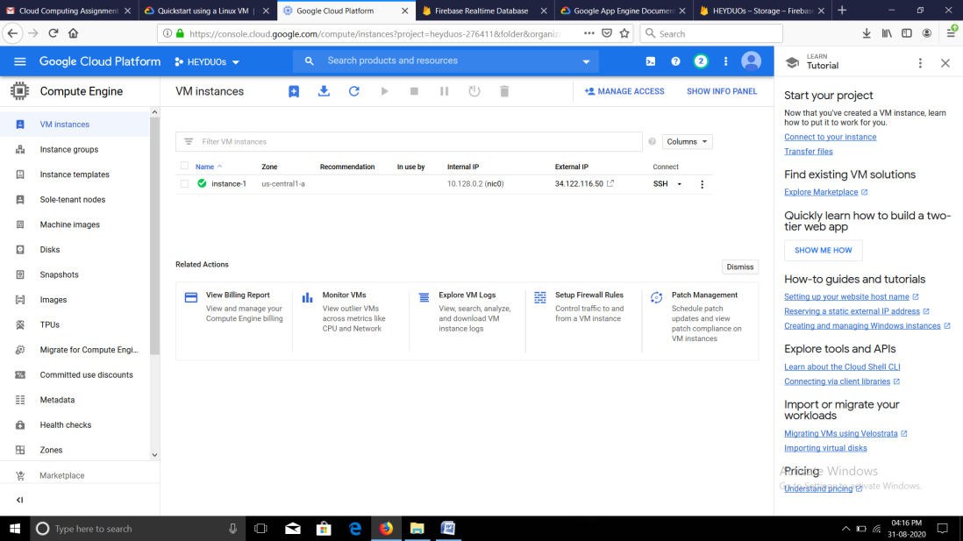

* + 1. Write detail steps for Deploy a simple Apache web server to learn the basics of running a server on a virtual machine instance. (Reference: <https://cloud.google.com/compute/docs/tutorials/basic-webserver-apache>)

Steps :

* Create Linux Instance.
* **Allow HTTP traffic**, which opens tcp:80 for traffic.
* **Install Appache**
* Use the Debian package manager to install the apache2 package.
* sudo apt update && sudo apt -y install apache2
* After installing Apache, the operating system automatically starts the Apache server.
* Overwrite the Apache web server default web page with the

following command:

* echo '<!doctype html><html><body><h1>Hello World!</h1></body></html>' | sudo tee /var/www/html/index.html
* Now Test server
* Go to the VM Instances page in the Google Cloud Console.
* Copy the external IP for your instance under the **External IP** column.
* In a browser, navigate to http://[EXTERNAL\_IP]. Do not connect using https, as the server will return a Connection Refused error.
* You should now see the "Hello World!" page.

# Google App Engine (Ref: <https://cloud.google.com/appengine/docs>)

App Engine is a fully managed, serverless platform for developing and hosting web applications at scale. You can choose from several popular languages, libraries, and frameworks to develop your apps, then let App Engine take care of provisioning servers and scaling your app instances based on demand.

* 1. Firebase database service (<https://firebase.google.com/docs/database/>)
* Firebase Database Provide service to store big data
* Two Data bases provided are Realtime database and Cloud Firestore
* To store files Firebase Storage is present

